Year Group |  | Autumn 1 |  | Autumn 2 | Spring 1 | Spring 2 | Summer 1 | Summer 2
EYFS |  | All About Me  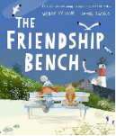  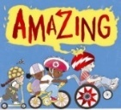 |  | Autumn/  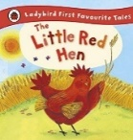  The Woodland  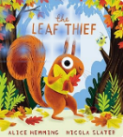 | Animals in Cold Countries: The Wider World  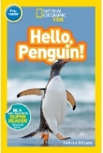  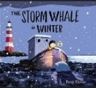 | Animals in Hot Countries: The Wider World  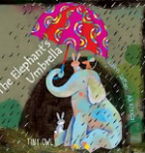  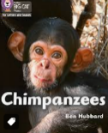 | Lifecycles  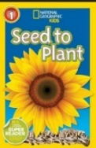  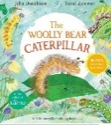 | Journeys  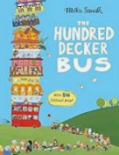  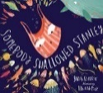
Year 1 | Author Spotlight | Roger Hargreaves |  | Julia Donaldson | Oliver Jeffers | Nick Butterworth | Beatrix Potter | Sue Hendra
Year 1 | English Text | A variety of traditional tales  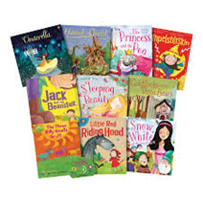 | 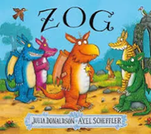  Zog by Julia Donaldson |  | Lost and Found by Oliver Jeffers  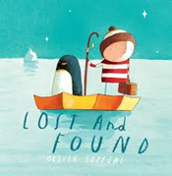 | 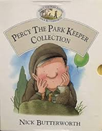  Percy the Park Keeper by Nick Butterworth | Peter Rabbit by  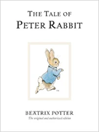  Beatrix Potter | No-Bot the Robot by Sue Hendra and Paul Linnet  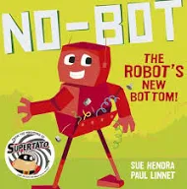
Year 2 | Author Spotlight | Janet & Allan Ahlberg |  | Lynley Dodd | Pip Jones | Jill Murphy | David McKee | Judith Kerr
Year 2 | English Text | The Jolly Postman by J&A Ahlberg  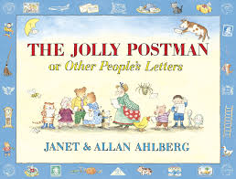 |  | Prince Cinders by Babette Cole  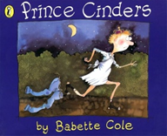 | Man on the Moon by Simon Bartram  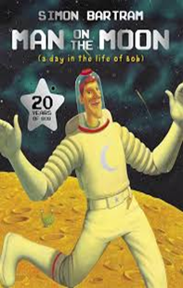 | Mossop’s Last Chance by Michael Morpurgo  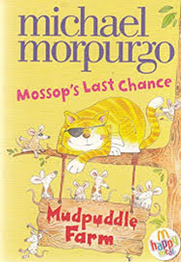 | Wind in the Willows  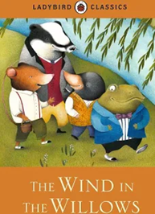 | The Lighthouse Keeper’s Lunch by  Ronda & David Armitage  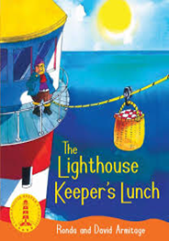
Year 3 | Author Spotlight | Jeremy Strong |  | Anthony Browne | Ann Cameron | Anne Fine/ Benjamin Zephanaih | Enid Blyton | Ibtihaj Muhammed
Year 3 | English Text | Folk Tales-  The Tin Forest by Helen Ward & Wayne Anderson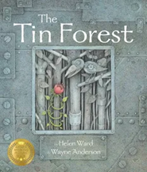 |  | Aesop’s Fables by Michael Rosen  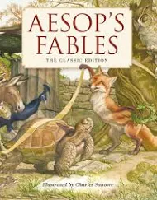 | Stig of the Dump by Clive King  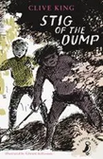  My Teacher is a Dinosaur and Other Prehistoric Poems  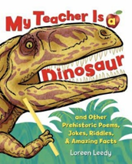 | The Iron Man by Ted Hughes  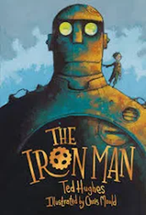 | Greek Myths by Marcia Williams  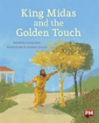  Playtime by Julia Donaldson  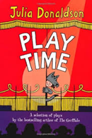 | The Enchanted Wood by Enid Blyton  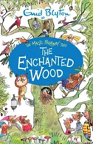  Plant by Dorling Kindersley Eye Witness Series  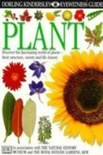
Year 4 | Author Spotlight | Philip Pullman |  | Terry Dreary | Allan Ahlberg | Roald Dahl | Tom Fletcher | Dick King-Smith
Year 4 | English Text | The Firework-maker’s Daughter by Philip Pullman  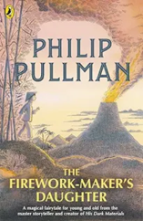  Until I Met Dudley by Roger McGough  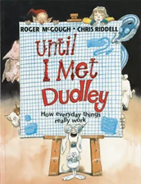 |  | The Pied Piper of Hamlin by Michael Morpurgo  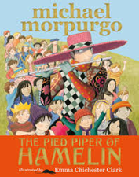 | ‘The Balaclava Story’ from The Fib by George Layton  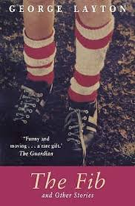 | Gulliver by Jonathan Swift  Gulliver’s Travels by Marie Cook  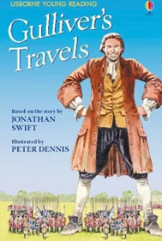 | The Mousehole Cat by Antonia Barber  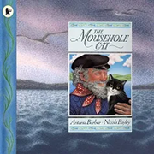 | Brer Rabbit by Enid Blyton  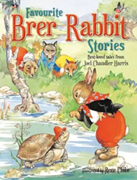  Brer Rabbit & The Tar Baby by Joel C Harris  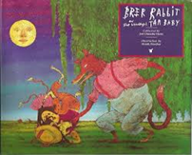
Year 5 | Author Spotlight | Jeff Kinney |  | Michael Rosen | Frank Cottrell Boyce | Graheme Baker-Smith | C S Lewis | Onjali Q. Rauf
Year 5 | English Text | Bedd Gelert  Beowulf by Michael Morpurgo  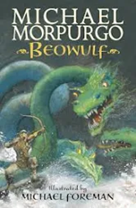 |  | Oliver Twist by Charles Dickens  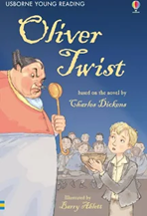  Timothy Winters by Charles Causley | Cosmic by Frank Cotrell Boyce  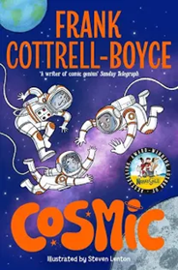 | The Invention of Hugo Cabret by Brian Selznick  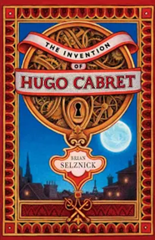 | Various myths  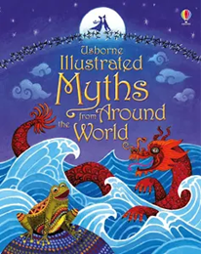 | Jumanji by Chris Van Allsburg  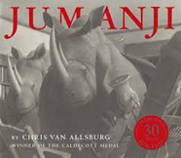
Year 6 | Author Spotlight | Michael Morpugo |  | Matt Goodfellow | William Shakespeare | Kwame Alexander | Louis Sachar | Malorie Blackman
Year 6 | English Text | Kensuke’s Kingdom by Michael Morpurgo  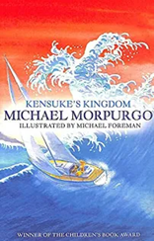 |  | Goodnight Mister Tom by Michelle Magorian  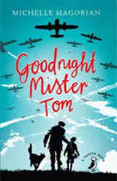 | Macbeth  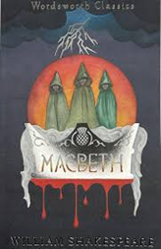 | Murder Most Unladylike by Robin Stevens  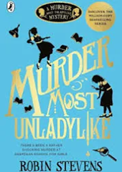 | Holes by Louis Sachar  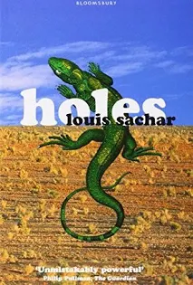 | Classic narrative poetry  

